**Assignment 2(a)**

In this assignment, we will use the definition of Normalization.

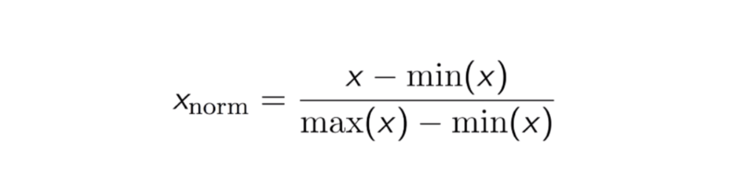

Normalization is an important concept used to centralize data for data processing.

Write a code which consists of the following functions:

1. ***normalize_data(float arr)*** which takes an ***array*** as input which consists of data values of data type ***float***. It should then manipulate this data and normalise it.
2. ***min(float arr)*** which takes an ***array*** as input which consists of data values of data type ***float***. It should then return the minimum value in this ***array.*** Recursion must be used to find this minimum value.
3. ***max(float arr)*** which takes an ***array*** as input which consists of data values of data type ***float***. It should then return the maximum value in this ***array.*** Recursion must be used to find this maximum value.

If you can’t figure out the logic of using recursion to find the min and max values, then you may use any other means to find them. But lesser points will be awarded for this.

**Assignment 2(b)**

In this assignment, we will be using the concept of slicing of string. This hasn’t been taught in class and encourages the student to learn concepts from the greatest teacher, ie, Google.

I will be teaching this concept after the assignments are submitted.

This shows the fact that not everything can be taught, and many at times, your real-life C++ applications would require Google searches to complete tasks.

Write a code which:

1. Takes a string of data types ***char*** as input with a maximum of 30 characters.
2. The input will be of the format “My name is x”, where x will be the name of the user.

Ex : “My name is Joel Antony Thomas.”

1. The program will then take an input of how many alphabets are there in the name(excluding the spaces)

Ex : 16(Joel = 4, Antony = 6, Thomas = 6. Hence a total of 16)

1. The program will then take an input of how many words there are in their name.

Ex : 3(Joel = 1. Antony = 1, Thomas = 1. Hence a total of 3)

1. The program now has to use the concept of slicing to only print the full name.

Ex : Joel Antony Thomas(this should be the final output)